

CIM 545: Managing Interactive Media Projects

Class Project

# Proposal

For

XYZ Corp

Size Me Up

XYZ Corp

**Prepared For:**

Client Name, Title, Company Name, Email, Phone

Project Reference #

**Prepared By:**

Jacqueline Stetson Pastore

Univ­­ersity of Miami CIM 545

[jstetson@uxrd.com](mailto:jstetson@uxrd.com)

(305) 409-3068

Proposal V2

February 3, 2016

# Revision History

|  |  |  |  |  |  |
| --- | --- | --- | --- | --- | --- |
| **Version** | **Date** | **Section** | **Change Description** | **Required By** | **Changed By** |
| 1.0 | 2/3/2016 | Project Details | Added Schedule, Budget, Payment Schedule | Jacqueline Stetson | Jacqueline Stetson |
| 1.1 |  |  |  |  |  |
| 1.2 |  |  |  |  |  |
| 1.3 |  |  |  |  |  |

# Project Overview

The University of Miami CIM 545 Managing Interactive Media Projects class is learning about how to create a project plan for a technology project.

The class project is for Size Me Up, an IOS mobile app that helps parents quickly measure their child’s foot and see what shoes in Miami-Dade County are available in that size at stores near them.

## Goals

Goals for this project include:

* Build an engaging application that helps parents and caregivers know what size a child’s foot is and shows local inventory.
  + Measured by 1 out of 5 active users per download after marketing efforts.
  + Measured by conversion rates through coupon codes.
  + Measured by 4 star rating on iTunes.
* Acquire 5 strategic partnerships with local retail establishments.
  + Measured by number of contractual agreements.
* Build a fast application.
  + Measured by the user being able to accomplish the core task of measuring a foot and finding a shoe at a store within a minute.

## Stakeholders

Stakeholders for the project are:

* Users
* Executives
* Development Department
* Design Department
* Business Partners

## Roles & Responsibilities

Team members for this project are:

|  |  |
| --- | --- |
| **Name** | **Role** |
|  | Product Owner / Project Sponsor |
|  | Project Manager / BA |
|  | UX Researcher |
|  | UX Designer |
|  | Visual Designer |
|  | Front-End Developers |
|  | Back-End Developers |

# Approach

CIM545 recommends following a user-centered design process for this project. This allows for closer interaction with the end-user through interviews and usability testing. By bringing the user into the product development lifecycle, we ensure that the final product is closer in-line with what the target population wants. This includes:

* Phase 1: Research. During the research phase of the project, we will reach out to users through user interviews and store intercepts. The goal during this phase is to flush out user types and user stories. We will also reach out to possible strategic partners for interest and technical details.
* Phase 2: Design. During the design phase, we will create interactive Axure wireframes based on the user stories identified in the Research phase. We will do usability testing on the wireframes to ensure they match user needs.
* Phase 3: Build. During the Build phase, we will build out the application. If possible, we can start portions of the phase early as we learn about our partners’ technical availabilities. We will conduct usability testing and QA on the final product and make any adjustments as needed.
* Phase 4: Release. We will do alpha and beta releases with limited user bases prior to our formal product release in the app store. Once we have released the final version of the product, we will then promote the product and gather feedback from users.

## Scope

CIM545 will complete the following activities and deliverables for each phase of the project.

### Phase 1: Research

#### Activities

* User Interviews – We will talk to parents and caregivers about their experience buying shoes for their children.
* Store Intercepts – We will observe parents in stores buying shoes for their children.
* Strategic Partner Exploration – We will identify all local retail companies that sell children’s shoes in Miami-Dade County. We will then reach out to all of them to identify if they are interested in participating in our product and what their technical capabilities are.

#### Deliverables

* Research Findings Presentation – We will create a powerpoint presentation based on research findings. This will include user types, personas, needs, pain points from the interviews and intercepts.
* User Stories in JIRA.
* Excel Spreadsheet of Possible Partners

### Phase 2: Design

#### Activities

* Interactive Wireframes – We will create interactive wireframes in Axure based on user stories.
* Usability Testing – We will conduct usability testing of wireframes to uncover usability issues in the design. If needed, we will adjust wireframes and test again.
* Design Documentation – Once we have final designs, we will annotate the wireframes, create style guides and mockups.

#### Deliverables

* Annotated Interactive Wireframes – Wireframes will demonstrate user stories and will be used in usability testing. After testing, they will be annotated for development.
* Usability Report – We will identify changes needed to happen to wireframes based on usability testing. These will be written out as a Powerpoint Presentation.
* PSD Visual Design Mockups of key pages.
* PSD Styleguide for the app.

### Phase 3: Build

#### Activities

* Development – We will build out the IOS app and any APIs or databases needed for our partners.
* Usability Testing – We will conduct usability testing on the final coded app. We will make any adjustments needed from high priority recommendations. Lesser recommendations will be prioritized into the backlog.
* QA – We will perform Quality Assurance testing across devices for all user stories.

#### Deliverables

* IOS app
* Usability issues as JIRA tickets
* QA issues as JIRA tickets

### Phase 4: Release

#### Activities

* Alpha, Beta, and Final Releases. We will do alpha and beta releases into the app store before officially launching the app. For each release, we will recruit users to use the app and give us feedback. We will do a third and final update for the app in the app store. This is the version that we will start to promote.
* Promotion. Once we have a live product in the app store, we will engage in promotional activities to get more users.

#### Deliverables

* 3 Versions of the app.
* Feedback change requests as JIRA tickets.
* Bug fixes as needed.

## Out of Scope

The following functionality is out of scope for V1 of Size Me Up:

* Online inventory
* In-app purchase
* Trend analytics

# Project Details

## Schedule

Below is a draft timeline of activities and deliverables.

|  |  |  |  |
| --- | --- | --- | --- |
| WBS# | Task | Timeline | Deliverables |
| 1.0 | Project Plan |  |  |
| 1.1 | Project Plan | Jan 11 – 22 | Project Plan |
| 1.2 | Sign Off | Jan 25 - 29 |  |
| 1.3 | Project Management Setup | Feb 1 – 12 | Github, Jira setup |
| 2.0 | Define |  |  |
| 2.1 | User Interviews | Feb 1 – 19 | Findings debrief |
| 2.2 | Store Intercepts | Feb 8 – 26 | Findings debrief |
| 2.3 | Partner Exploration | Feb 10 – Mar 4 | List of potentials & actuals |
| 2.4 | Findings Presentation | Mar 7 - 18 | Findings |
| 2.5 | User Stories | Mar 21 - 25 | User Stories |
| 3.0 | Design |  |  |
| 3.1.1 | Interactive Wireframes Concepts | Mar 28 – Apr 15 | Axure wireframes |
| 3.1.2 | Internal Design Review | Apr 18 - 22 |  |
| 3.1.3 | Usability Testing | Apr 18 – May 6 | Findings debrief |
| 3.1.4 | Iterate Wireframe Design | May 9 - 13 |  |
| 3.1.5 | Annotate Wireframes | May 16 - 20 | Annotated wires |
| 3.2.1 | Visual Design of Key Pages | May 16 – Jun 3 | PSD mockups |
| 3.2.2 | Style Guide | Jun 6 - 10 | PDF styleguide |
| 4.0 | Develop |  |  |
| 4.1 | Review User Stories | Jun 13 - 18 |  |
| 4.2 | Technology Setup | Jun 20 - 24 |  |
| 4.3 | Data Models | Jun 27 – Jul 1 |  |
| 4.4 | Front-end Development | Jul 3 – Aug 12 | Mobile app |
| 4.5 | Back-end Development | Jul 3 – Aug 12 | Mobile app |
| 4.6 | Test | Aug 15 – Sep 16 |  |
| 4.7 | Iterate | Sep 19 - 23 | Mobile app |
| 5.0 | Release |  |  |
| 5.1 | Beta Test | Sep 26 – Oct 21 | Iterate on product |
| 5.2 | Soft Launch | Oct 24 – Nov 25 |  |
| 5.3 | Promote | Nov 28 – Dec 16 |  |
| 6.0 | Close Project |  |  |
| 6.1 | Post Mortem | Dec 19 | Recap |
| 6.2 | Strategy Planning | Dec 20 - 23 | Roadmap |

## Budget

Below is project costs broken down by phase.

|  |  |  |  |
| --- | --- | --- | --- |
| WBS# | Task | Detail | Cost |
| 1.0 | Project Plan & Mgmt | Salaries | $201,000 |
|  |  | Subscriptions | $420 |
| 2.0 | Define | Salaries | $24,000 |
|  |  | Honorariums | $500 |
| 3.0 | Design | Salaries | $46,000 |
|  |  | Honorariums | $200 |
| 4.0 | Develop | Salaries | $77,000 |
|  |  | Honorariums | $200 |
| 5.0 | Release | Salaries | $23,000 |
|  |  | Marketing Budget | Not Included |
| 6.0 | Close Project | Salaries | Included |
|  |  | **Total** | **$372,320** |

## Payment Schedule

Payment terms for this project are:

* 25% due at time of engagement for services
* 25% due at conclusion of Phase 1 (Research & Define)
* 25% due at conclusion of Phase 2 (Design & Usability Testing)
* 25% due at conclusion of project (post launch)

# Appendices

## Appendix A - Work Breakdown Structure

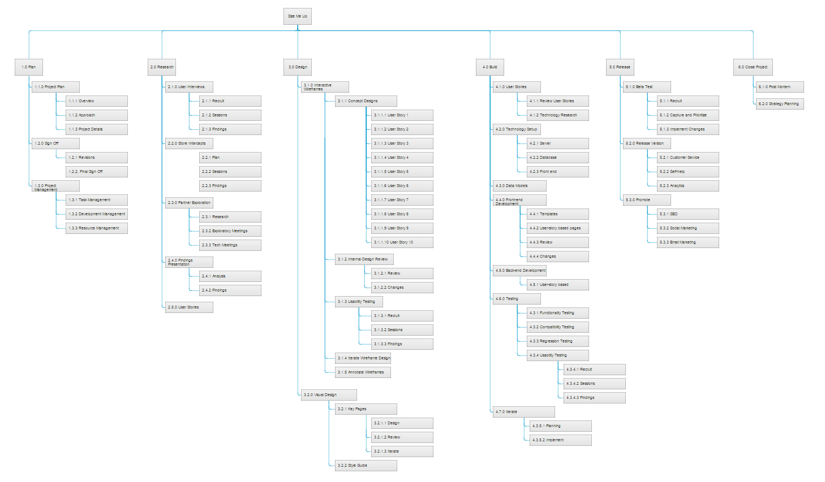

## Appendix B - Gantt Chart

